­

**Subject**

Vietnamese restaurant recommendation service

**Abstract**

**Overview of the Project**

Travel review data is collected from various sources, feature values of eachrestaurant are extracted, restaurants are classified, travel-related questions areprovided to users, and user answers are analyzed to identify preferred features.Recommend the best restaurant for the user using the appropriate recommendationalgorithm.

**Outline and Background**

**1. Variability of restaurant information**

Vietnam consists of various regions and cities, and each region has its ownunique food culture and restaurants. However, it is difficult for these languageusers to decide where and what food to eat. This information is scattered fromvarious sources such as the Internet, travel guidebooks, and recommendationsfrom acquaintances, making it cumbersome for travelers to invest time to obtaininformation on local restaurants.

**2. Universal recommendation service**

Most of them are general travel destination recommendation services that do nottake into account the food style, restaurant interior, dietary restrictions and tastesthat users pursue. Therefore, users obtain information about restaurants that arenot suitable for them.

**Key Project Features**

Restaurant recommendations

1. Classification classification according to characteristics

2. Identify the user's taste in foodTeam VisitViet 2

3. estaurant recommendations

**Benefit of the Project**

1. Integration of various restaurant information

2. Recommended restaurants

3. Local Food and Welfare Support

**Flowchart**

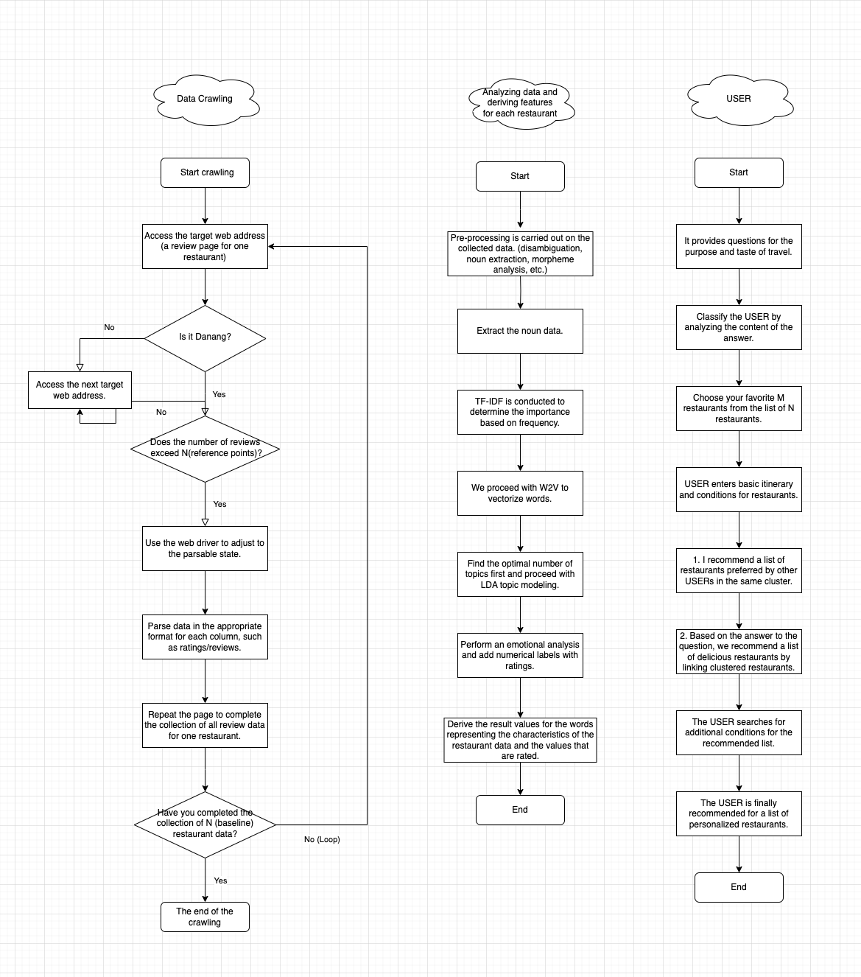

**Name Mobile**

Hyeri Bae : (+82)-010-3283-4053

Haseong Jung : (+82)-010-3929-8012